#### Duck Hunt – Design Document

# Github Repository

<https://github.com/IJustDrankALavaLamp/RetroGame>

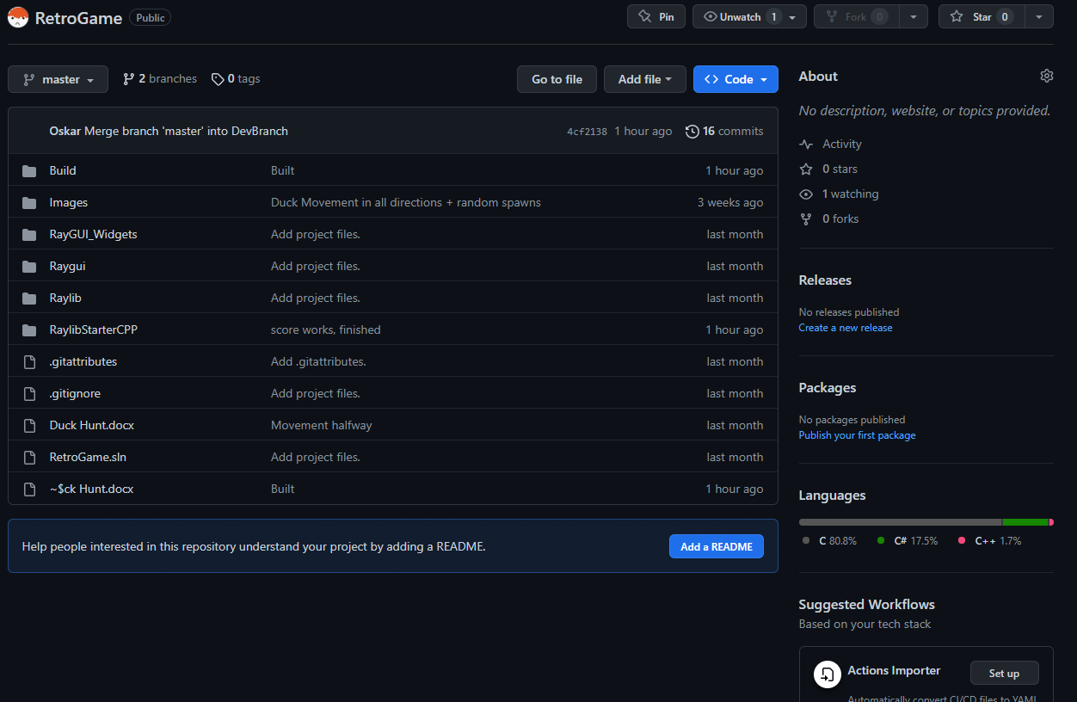

# Introduction

For the Retro game I plan on making a basic version of Duck Hunt. The game will mainly feature moving targets that spawn from random positions off screen and move onto the screen going different directions. The aim of the game will be to get as high scoring as the player can, the score going up from shooting the targets that appear on screen.

# Algorithms

## Game

## SceneObject

The SceneObject algorithm will be a template for basic objects on screen contain movement, drawing and collision functions, though will be expanded on through other scripts .

## Duck : derived from SceneObject

The duck Object will contain its own functions to generate random spawn positions and have the ability to check whether the object is still contained on screen. It will also be able to tell if the object is a duck so that when doing functions that apply to all objects but have different outcomes to ducks the main function will be able to tell.